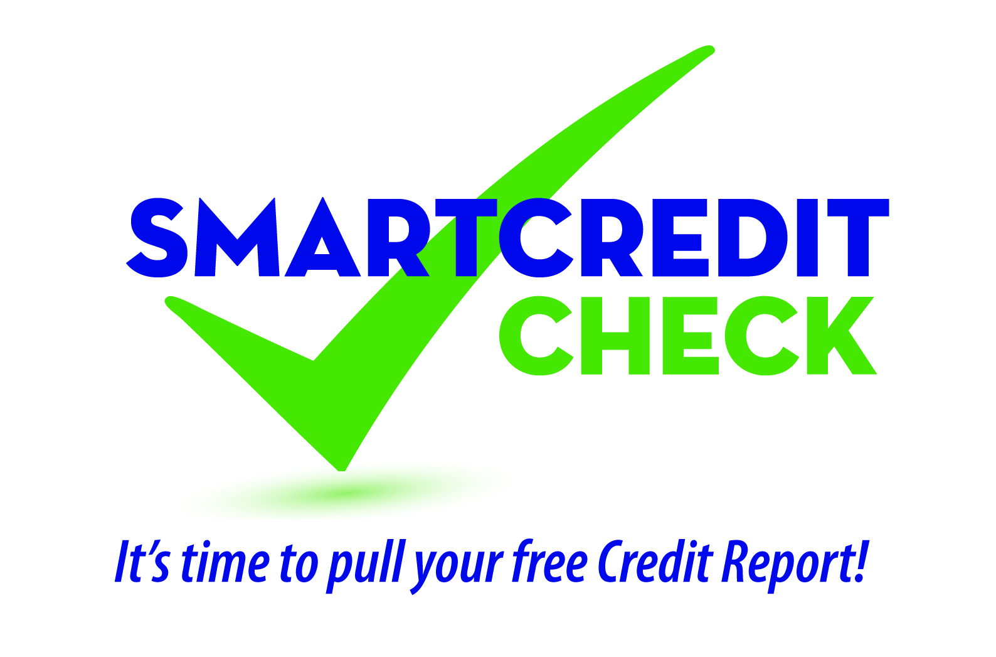

SMART Credit Check Seminar Evaluation:

We are interested in knowing how helpful this seminar was for you. Please take a few minutes to answer the following questions. We appreciate your feedback.

(-) (+)
1. What is your overall rating of this seminar? 1 2 3 4 5

2. How well was the information presented? 1 2 3 4 5

3. To what degree did the seminar help you understand 1 2 3 4 5
the importance of checking your credit report?

4. To what degree did this seminar help you understand 1 2 3 4 5
how important it is to maintain good credit?
5. Do you have a better understanding of how Yes___ No___
to order your free annual credit report?
6. Do you have a better understanding of how to correct Yes___ No___
errors on your credit report?

7. Do you know what to do if you are a victim of ID theft? Yes___ No___

8. Would you recommend this seminar to others? Yes___ No___

9. What did you like best about this seminar? Please be specific if possible: _________________________________

_______________________________________________________________________________________________

10. What would you change to make this seminar better? Please be specific if possible. ______________________

_______________________________________________________________________________________________

(Optional) For aggregate reporting please provide the following:

Do you currently have an account at a Credit Union or a Bank? ______Yes ______No Current Zip Code ______________

Age: ________(18-25) ________(26-55) ________(over 55)

Education: ________(Some High School) ________(High School)
________(Some College) ________(College Graduate or higher)

Household Income _______(Under $25K) _______($25-$40K) _______(40-$80K) _______ ($80K+)

Is English the primary language spoken in your home? ________Yes ________No

Are you currently in the military? ________Yes ________No
Thank You!

