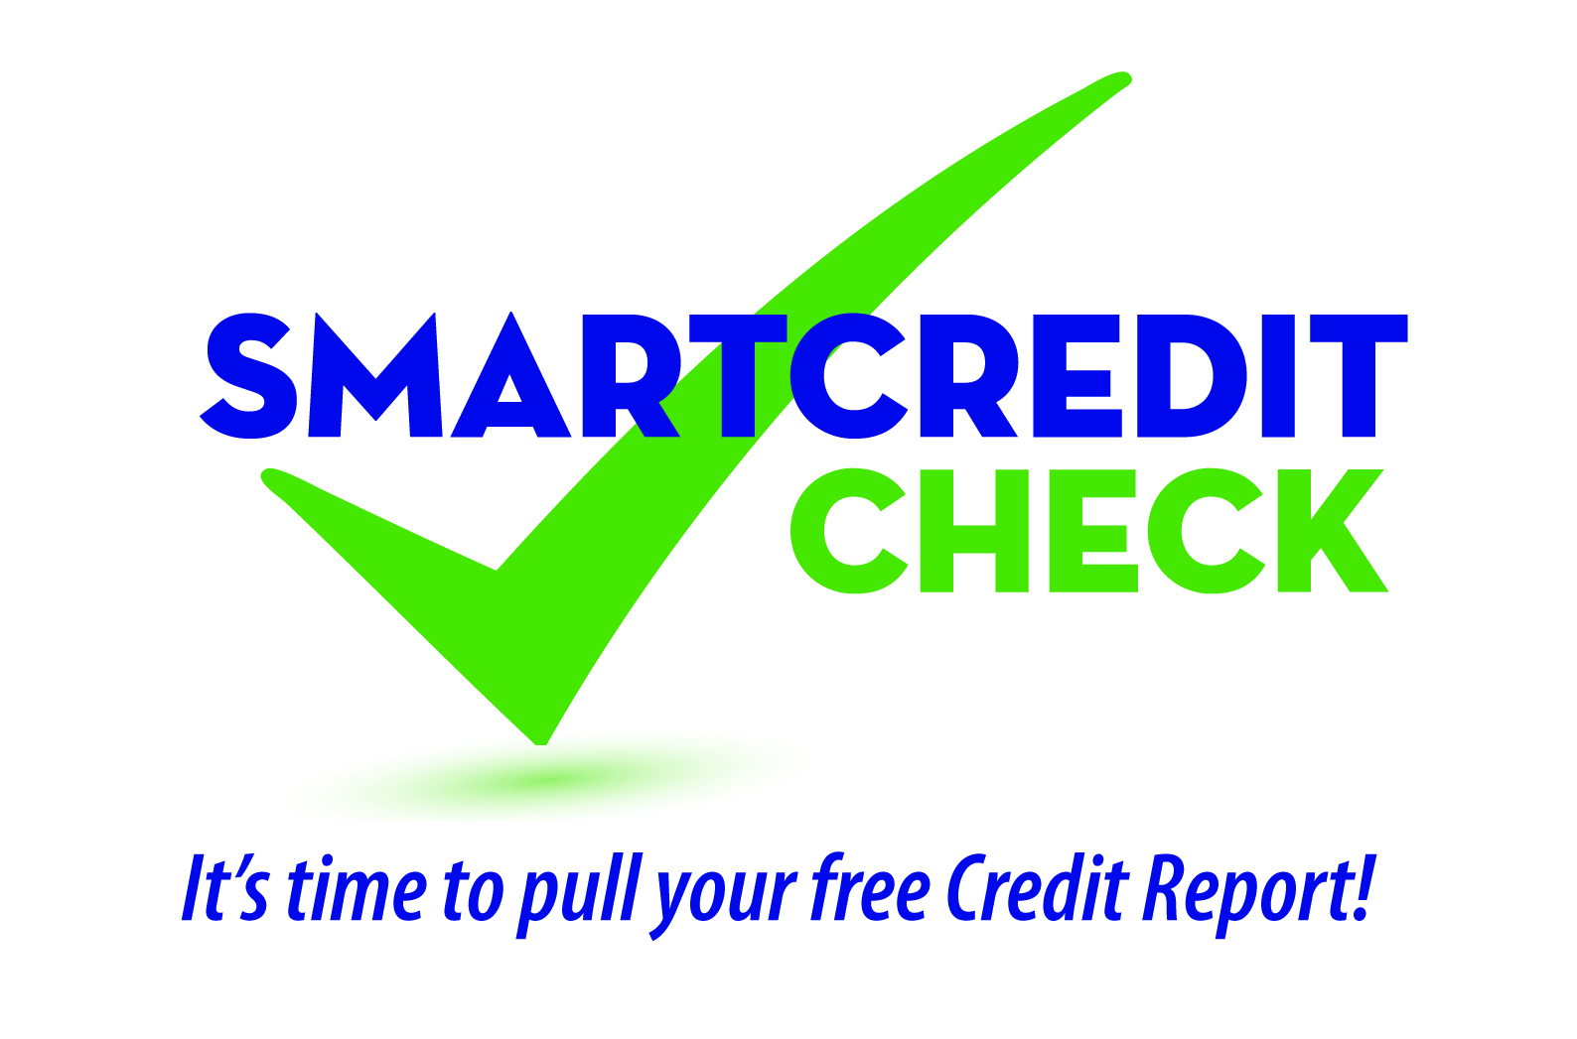

Social Media Posts

Example Facebook Posts

Option 1
This month the Credit Unions Care Foundation of Virginia is teaming up with credit unions across the state for SMART Credit Check to remind Virginians to periodically pull and review their credit reports for financial safety and soundness. Learn more here: XXXXXXXXX.
(Editor’s note: create a hyperlink to your website where you have posted your SMART Credit Check press release. Link “Credit Unions Care Foundation of Virginia” to http://www.creditunionscarefoundation.org/index.html.

Option 2
Checking your credit report regularly is a crucial step in protecting yourself from fraud or inaccurate reporting which could impact your credit score and result in other costly consequences. At our upcoming free SMART Credit Check financial education seminar, learn how to obtain and decipher your credit report and use this tool to improve your credit and monitor for identity theft. Find out more and register today.
(Editor’s note: create a hyperlink to your website where you have posted information on your upcoming SMART Credit Check seminar.)

Option 3
Need help making sense of what’s in your credit report? We’re happy to sit down one-on-one with you to help you understand your credit report’s content, find ways to improve your credit, and possibly save you money. To schedule an appointment, please email XXXXXXXXX or call XXX-XXX-XXXX.

Option 4
To guard against losses and inconvenience from identity theft, review your credit reports regularly. You can order one free credit report a year from each of the “big three” credit reporting agencies—Equifax, TransUnion, and Experian—at annualcreditreport.com. Learn more here: XXXXXXXX
(Editor’s note: create a hyperlink to your website where you have posted the SMART Credit Check educational newsletter article. Choose either: Newsletter “Option 1 - Have You Reviewed Your Credit Report Lately?” or Newsletter “Option 2 - It’s Time To Pull Your Credit Report – Learn why!” Also, link to https://www.annualcreditreport.com/index.action.)
Option 5
When is the last time you reviewed your credit report for accuracy or identity theft? Don’t know how to start? We can help. Learn more here: XXXXXXXX
(Editor’s note: create a hyperlink to your website where you have posted the SMART Credit Check educational newsletter article. Choose either: Newsletter “Option 1 - Have You Reviewed Your Credit Report Lately?” or Newsletter “Option 2 - It’s Time To Pull Your Credit Report – Learn why!”)

Option 6
Approximately how many people have errors on their credit report?
- 10 million consumers
- 20 million consumers
- 40 million consumers
- 60 million consumers
For the correct answer and to learn how to discover if you are one of these consumers, click here: XXXXXXXXX.
(Editor’s note: create a hyperlink to your website where you have posted the SMART Credit Check educational newsletter article: “Option 2 -It’s Time To Pull Your Credit Report – Learn why!”)

Option 7
Your credit report can affect your ability to purchase a home, rent an apartment, buy a car, receive favorable insurance rates, or even get a new job. Additionally, checking your credit report regularly is a crucial step in protecting yourself from fraud or inaccurate reporting. Learn how to get a free copy of your credit report here: XXXXXXXXX.
(Editor’s note: create a hyperlink to your website where you have posted the SMART Credit Check educational newsletter article. Choose either: Newsletter “Option 1 - Have You Reviewed Your Credit Report Lately?” or Newsletter “Option 2 - It’s Time To Pull Your Credit Report – Learn why!”)

Option 8
Get your free credit report the SMART way!
(Editor’s note: create a hyperlink to your website where you have posted the SMART Credit Check educational newsletter article: “Option 4 - Get your free credit report the SMART way!”)

General Tip: upload one of the campaign’s graphics and link to any of the SMART Credit Check content articles and/or seminar announcements you’ve posted on your website.
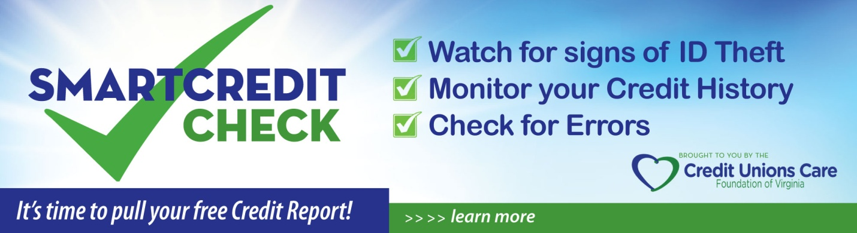
Example Twitter Posts

Option 1

YOURCUNAME joins statewide effort to remind you to pull your credit report. Insert link.

(Editor’s note: link to your SMART Credit Check press release on your website.)

Option 2

Mark your calendar! SMART Credit Check seminar @YOURCUNAME on Jan XX at X:XXpm ET. Insert link.

(Editor’s note: link to your SMART Credit Check seminar information on your website or community calendar.)

Option 3

Learn how to obtain and review your free credit report @SMART Credit Check seminar. Get details here: Insert link.

(Editor’s note: link to your SMART Credit Check seminar information on your website or community calendar.)

Option 4

Are you one of the 40 million with an error on your credit report?

(Editor’s note: create a hyperlink to your website where you have posted the SMART Credit Check educational newsletter article: “Option 2 - It’s Time To Pull Your Credit Report – Learn why!”)

Option 4

Get 1on1 help to review your credit report to find ways to improve your credit score and save $$$. Contact us for appointment.
(Editor’s note: create a hyperlink to your contact information on your website or web content explaining your credit report review appointment options.)

Option 5
Get your free credit report the SMART way!
(Editor’s note: create a hyperlink to your website where you have posted the SMART Credit Check educational newsletter article: “Option 4 - Get your free credit report the SMART way!”)

