Tips for Pulling Your Credit Report

Have you checked your credit report for fraudulent activity or mistakes?
Do you want to know what is in your credit report, but aren’t sure how to order a copy?

According to the Fair Credit Reporting Act you are entitled to receive one free credit report every 12 months from each of the nationwide consumer credit reporting companies. You can decide to order all three credit reports at once or stagger your requests throughout the year.

- If you are preparing to make a large purchase like a car or house, then ordering all three reports at the same time allows you to check each report for accuracy and correct any mistakes prior to applying.

- Staggering your requests offers you more frequent access to some of your information and can help you keep track of changes and look for warning signs of identity theft on a more frequent basis.

To access your free annual credit report online, follow the simple steps below:

Step 1
Visit annualcreditreport.com, the only FTC approved source for your free credit reports.

Step 2
Click the red “request your free credit reports” button.

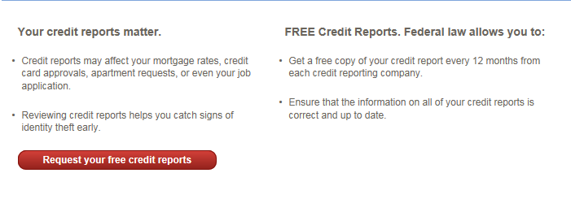
Step 3
Complete the online form with your personal information. You will be asked a few questions about items on your credit report as a method of safeguarding your information. Consider pulling your report from a location that allows you easy access to your financial records in case you do not readily know the answer to a security question.

To order your free annual credit report by phone call: 1-877-322-8228.

To order your free annual credit report by mail: Complete the Annual Credit Report Request Form.
This downloadable form can be found at www.consumer.ftc.gov/articles/0155-free-credit-reports. Follow directions on the form carefully and mail in a #10 envelope to:

Annual Credit Report Request Service
P.O. Box 105281
Atlanta, GA 30348-5281

