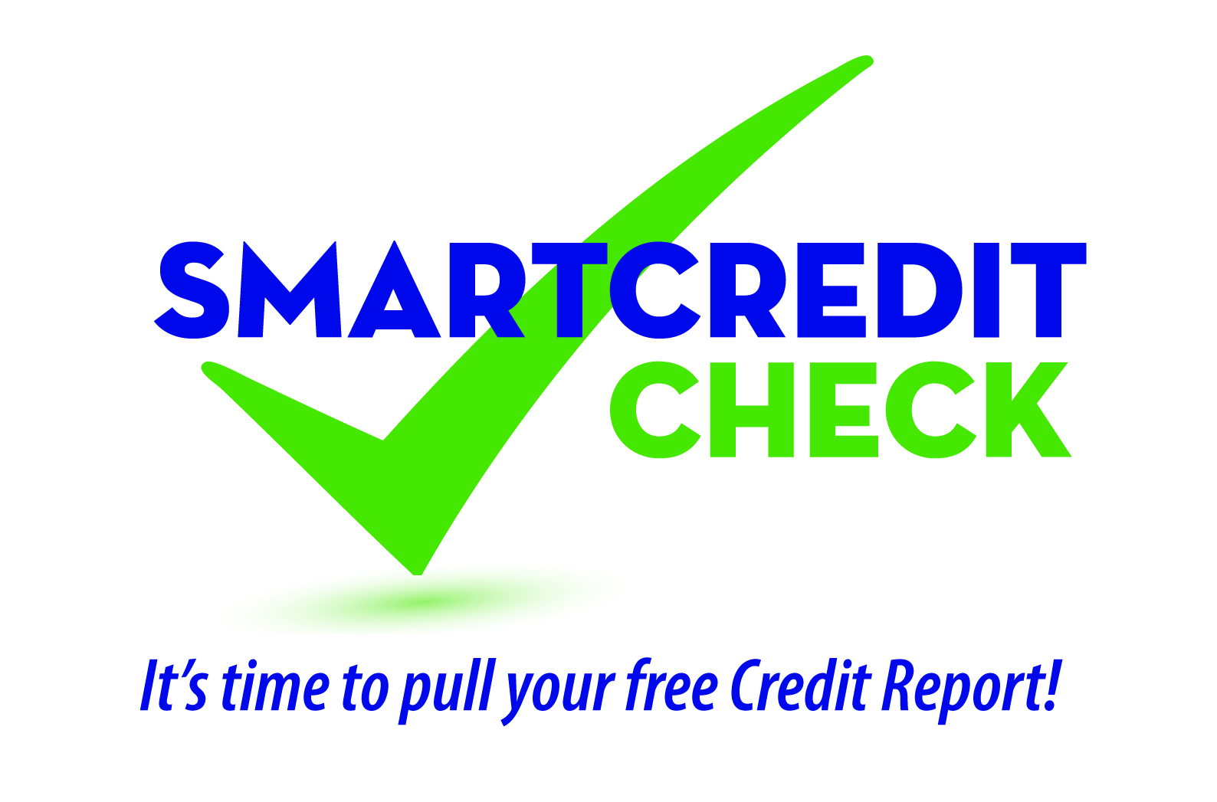

Member Education Tool Kit Checklist

The below instructions are provided to help you develop your seminar participant handout packages.
Left side of Folder
- Seminar Evaluation
- Member Copy of PowerPoint Slides
Right side of Folder (Handouts)
Recommended order of handouts from front to back which corresponds to the PowerPoint.
- Icebreaker: Credit Truths or Myths
- FTC’s Opt Out of Prescreened Credit and Insurance Offers
- Experian Sample Credit Report
- Tips for Pulling Your Credit Report
- Annual Credit Report Request
- Sample Credit Dispute Letter
- Sample Creditor Request Letter
- Credit Missteps Impact on Credit Scores
- Protect Your Information
- Picking a Secure Password
- Credit Report Security Freeze
- What to do if you are a Victim of ID Theft
Optional Material
- Credit Unions Care Foundation Brochure
- The Federal Trade Commission offers free downloadable videos and content you can reproduce:
For videos visit: www.consumer.ftc.gov/media
For content fact sheets, search by topic at: www.consumer.ftc.gov
- CUNA brochure #23557C Keeping Score: Facts About Credit Scores
- CUNA brochure #27319-PRO Good Habits: Protect Your Cards Against Fraud
- CUNA brochure #25740-PRO Your Rights Under the Fair and Accurate Credit Transactions Act

