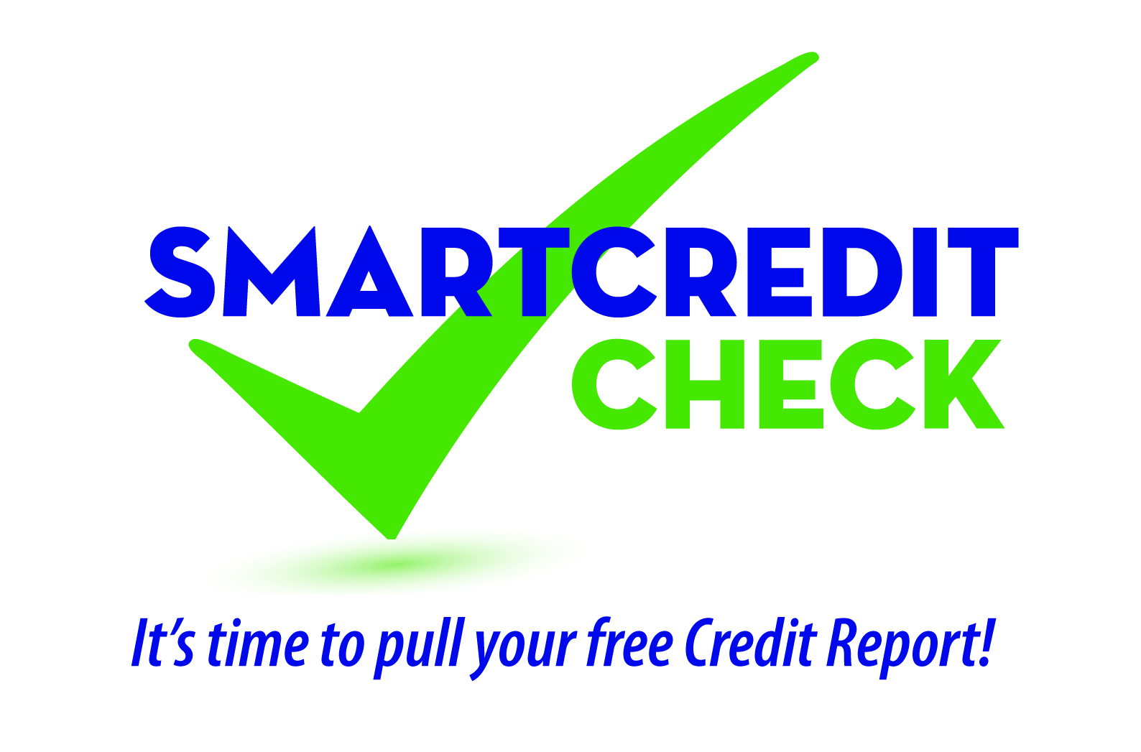

Member Seminar Description

Use for seminar calendar or mass email invitation.

Seminar Topic: SMART Credit Check
Your credit report contains all kinds of information used by lenders, insurance providers, employers, landlords, cell phone providers and others to make decisions on whether or not they should do business with you. Shouldn’t you know what’s in it? Join us to learn how to safely obtain your free credit report, how to detect and correct errors in your report that could impact your credit score, how to use your report to monitor for id theft and what steps you should take if you are a victim. You’ll leave this session with actionable items to improve your credit score and overall financial well-being.
Optional paragraph: Bring a copy of your latest Equifax, Experian, or TransUnion credit report to your appointment. You can get one, or all three, free annually from annualcreditreport.com. Credit Union representatives will be on hand to answer one-on-one questions about your credit report(s) after the seminar.
To RSVP as seating is limited, contact: [insert your information here].

