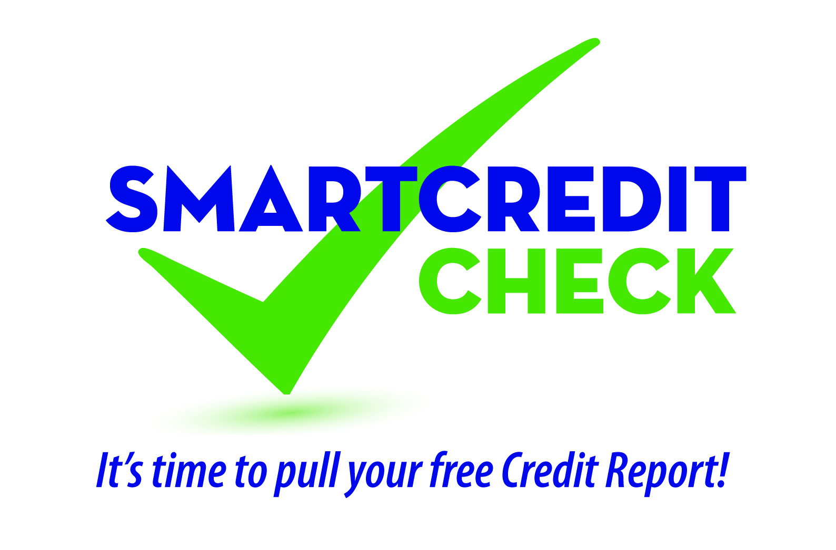

Educational Newsletter Articles/Web Content Options

Option 1

Have You Reviewed Your Credit Report Lately?
Your credit report is an important tool; order your copy today so you can:
- Spot warning signs of identity theft
- Find reporting errors
- Understand how to improve your credit

That’s why the Credit Unions Care Foundation of Virginia and credit unions across Virginia have partnered to remind you to periodically review your credit report. The law allows you one free copy of your credit report each year from each major reporting agency (Equifax, Experian, TransUnion).

It’s easy; just visit www.AnnualCreditReport.com where you can order all three reports at the same time or one at a time to stagger throughout the year.

To learn more join us for SMART Credit Check Seminar on [Date, Time, Location]. Please RSVP by [calling XXX-XXX-XXXX or registering online at CU website.]

Need help reviewing your credit report? No problem. Contact us today at [insert contact info] to book a free confidential appointment with one of our credit union representatives. We might even find you ways to save money and improve your credit score!

Editor’s Note: The last two paragraphs can be modified depending on the events your credit union elects to offer during this campaign. They can be deleted entirely if you just want this article to be a straight education piece. You may also want to consider adding, if you are conducting a seminar event, to encourage you members to pull their credit reports and bring them to your session if you have the logistics to do this.

Option 2

It’s Time To Pull Your Credit Report – Learn why!
If you haven’t checked your credit report lately, the Credit Unions Care Foundation of Virginia and credit unions across the Commonwealth, including [insert your credit union name], want you to make this a priority.

For more than a decade identity theft has been at the top of the Federal Trade Commission’s list of complaints, and according to Javelin Strategy & Research, in 2013 over 13 million people were victims of identity fraud. Reviewing your credit report can help you discover accounts you didn’t open or debts you didn’t incur that were initiated by an identity thief.

Additionally, a 2013 Federal Trade Commission study found about 40 million consumers have errors on their credit reports, some of which could have an impact on credit scores.

That’s why your credit union wants to remind you to order and review your credit report. The Fair Credit Reporting Act allows you to obtain one free copy annually from each of the major credit reporting agencies (Equifax, Experian, TransUnion).

It’s easy; just visit www.AnnualCreditReport.com where you can order one or all three reports at the same time. You may want to consider staggering your requests throughout the year to help monitor for identify theft on an ongoing basis. For example, order a free report from Experian in January, then order from Equifax in May, and then in September from TransUnion. The following year, start over with a free report from Experian.

Your credit report is an important tool; order your copy today so you can:
- Spot warning signs of identity theft
- Find reporting errors
- Understand how to improve your credit

You’re Invited – Free Financial Education Seminar
To learn more, join us as we present a SMART Credit Check seminar on this important topic on [Date, Time, Location]. Please RSVP by [calling XXX-XXX-XXXX or registering online at CU Website.]

Additionally, we’re happy to sit down one-on-one with you to review our credit report to help you understand its content, find ways to improve your credit, and save you money. To schedule an appointment, [please call XXX-XXX-XXXX].

Editor’s Note: The last two paragraphs can be modified depending on the events your credit union elects to offer during this campaign. They can be deleted entirely if you just want this article to be a straight education piece. You may also want to consider adding, if you are conducting a seminar event, to encourage you members to pull their credit reports and bring them to your session if you have the logistics to do this.

Option 3

Understanding Your Credit

Your “Credit Report Grade” – Your Credit Score
Believe it or not, there is actually a story behind this all-important number. Much like how an academic grade is determined by academic performance, your credit score is a reflection of your credit performance. Everything from types of credit to payment history can affect this number.

To get an idea, ask yourself these questions: What credit lines do I have? A car loan? A credit card? A cell phone? How long have I had them? Also, consider this: Do I pay my bills on time? Just as your grade is lowered for turning in assignments late, your credit score takes a hit when you pay your bills late.
Checking Your Credit Grade
Interestingly, many consumers don’t even check their credit. According to the National Foundation for Credit Counseling’s 2013 Consumer Financial Literacy Survey, 65% of respondents failed to check their credit report within the past year¹. Would you go through a year of class without checking your grades to ensure they were accurate? Of course not.
The same idea should be placed on checking your credit report. In fact, it might be to your score’s benefit. According to a study done by the Federal Trade Commission, one in four consumers identified errors on their credit report that might affect their score².

Identity Theft Can Hurt Your Credit
Keeping track of your credit report is also vital to checking for credit “cheaters,” or those that want to steal your identity and good credit record for their gain and your loss. Identity theft can cost you money, lost credit opportunity and years of work to clean up.
www.AnnualCreditReport.com
To make it simple, the federal government provides an online site to check your credit once a year FOR FREE with each credit bureau: Equifax, TransUnion and Experian. Go to www.AnnualCreditReport.com to retrieve a copy of your report today.
We’re Here to Help!
[YOUR CREDIT UNION] is here for you! Bring in a copy of your report and we will be happy to go over it with you. We may even find opportunities to save you money! Call [CU phone number] or go online today at [CU website] to set up an appointment with a member service representative.

1.http://www.nfcc.org/NewsRoom/FinancialLiteracy/files2013/NFCC_NBPCA_2013%20FinancialLiteracy_survey_datasheet_key%20findings_032913.pdf
2. http://www.ftc.gov/news-events/press-releases/2013/02/ftc-study-five-percent-consumers-had-errors-their-credit-reports

Editor’s Note: Last paragraph can be modified to invite your members to your SMART Credit Check seminar session.

Option 4

Your Free Credit Report the SMART Way!

Tips to pull your free annual credit report:
- According to the Fair Credit Reporting Act you are entitled to receive one free credit report every 12 months from each of the three consumer credit reporting bureaus.
- Order all three at once or stagger your requests throughout the year. Staggering your requests offer you more frequent access to your information so you can keep track of changes and look for warning signs of identity theft on a more frequent basis.
- Find a secure location to pull your credit report, preferably from your secure network at home.
- Visit annualcreditreport.com, the only Federal Trace Commission (FTC) approved source for your free credit reports, and click the “request your free credit reports” button. You will be asked a few questions about items on your credit report as a security precaution so it might help to have access to your financial records. Complete form as directed.
- Annualcreditreport.com also has a request form that you can mail in to receive a copy of your reports. Consider shading the circle on the bottom right that requests only the last four digits of your social security number appear on records. Mail the request from a secure Postal Box or at your local Post Office.

Tips to reviewing your credit report
- Review each credit report thoroughly to ensure that the information is accurate.
- Pay careful attention to recent consumer initiated inquiries. New applications for credit lines you don’t recognize could be a warning sign of identity theft.
- If you find inaccuracies in your credit report file an online dispute form with the bureau that contains the incorrect information. If you suspect identity theft complete an initial fraud alert with any of the bureaus, contact the FTC at www.ftc.gov/idtheft and your credit union right away.
- Mark your calendar so you will remember to order your free reports every year.

