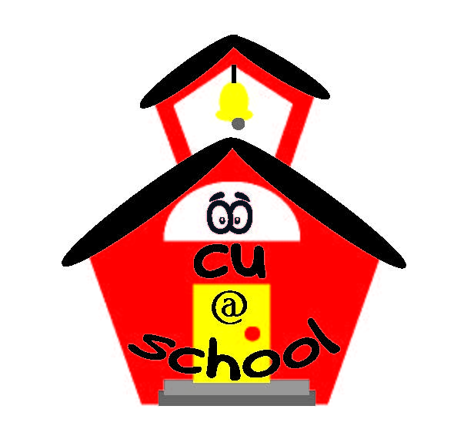
Summary: Sammy’s Big Dream. Sammy and his class have worked hard and won a contest. They win a prize but will cost them to go. Sammy has to save money and make choices based on his goal of getting to ride the roller coaster in space. While Sammy is trying to save money, he learns that at times you have to work hard for things you want and that not everyone will get what they want. But he continues to push through and meet his goal and in the end has enough to help his best friend go on the roller coaster as well.
Kindergarten:
SOL Requirements
- Economics K.7 – The student will recognize that people make choices because they cannot have everything they want; and explain that people work to earn money to buy the things they want.
- Math K.7 – The student will recognize a penny, nickel, dime, and quarter and will determine the value of a collection of pennies and/or nickels whose total value is 10 cents or less.
Objective: The student will learn that they will have to make choices at some point to determine what they may want or need more than something else. They will learn that they will have to work hard and save money for things that they may want or need.
Lesson:
- Read Sammy’s Big Dream to the class.
- After reading, have a discussion with the class about how Sammy had to choose not to buy certain things he may have wanted to help him save enough money.
- Have coins printed out and laminated; either holding them up or placing them on the board and having the students say which coin it is and its value. Then have the students show or tell you how many pennies you need to make ten cents. How many nickels you need to make ten cents. How many pennies it takes to make a nickel.

